**Appendix 1: Planning Guide**

Task 0 : Explain what you are doing/ going to accomplish

I am going to make a product page for my canteen in this version

Task 1: Sketch interface design

*Draft a rough design for the interface that allows the user to trigger functionality in task 1, while also annotating where the information in task 2 will be displayed. Create another sketch listing the interface widgets used to create the interface.*

Task 2: Identify any classes required

*Explain what the class will represent, plus listing what information will be stored in the class and any functions the class will have.*

N/A

Task 3: Identify information to be displayed

*What information will the interface need to display to the user?*

I am going to display a menu of food to the user

Task 4: Identify user inputs

*What program functions can the user trigger through the interface?*

*N/A in this version*

Task 5: Identify any constants or existing data if required

N/A

Task 6: Identify indexed data structures

I am creating food_list to hold all of my food items in

Task 7: Determine what calculations are necessary

*Write out the calculations the program will have to compute.*

Data = dict(food_list = food)

Task 8: Develop a modular structure for your program

*Describe any functions that the computer program will have, identifying any sub-functions where required.*

DEF CANTEEN():

This will be the page where users will be able to view a menu of food items that they can buy

Task 9: Define the functions identified

*Describe the functions for both the main program and any classes in terms of input and/or output where required. You may choose to do this with flow charts or pseudo-code (not Python code!). Add in additional steps or explanations using sequential, conditional, iterative statements where required. Identify global and/or local variables.*

|  |
| --- |
|  |
|  | route will be /menu |
|  | View will be menu |
|  | PROGRAM Canteen: |
|  | data = dict(food_list = Food) |
|  | return data |
|  |  |

I will also need some python code inside of my html:

% for item in menu_list:

<div class="card">

<div class="card blue-grey darken-1">

<div class="card-content yellow-text">

<h4><b>{{food.name}}</b></h4>

<p>{{food.stock}}</p>

<p>{{food.price}} dollar dollar bills yo</p>

</div>

</div>

%end

Task 10: Address any relevant implications such as usability, functionality, legal/ethical requirements.

Task 11: Document test cases for testing the program

*Document any testing that can be used to test your program. If any input is inputted using the keyboard, describe the expected input, plus any exceptional, boundary or invalid cases.*

I tested my case by running it and opening the page I created in localhost:8080

Task 12: Refine the plan

*Note any modifications here when iterating through the development cycles.*

I needed to slightly modify my html code so that instead of displaying food.price (non existant as I said to put each ITEM not food on display for each user) it showed item.price

Task 13: Document testing

*Show screenshots of your program working with descriptions of each image. These images should test the tests cases listed above.*

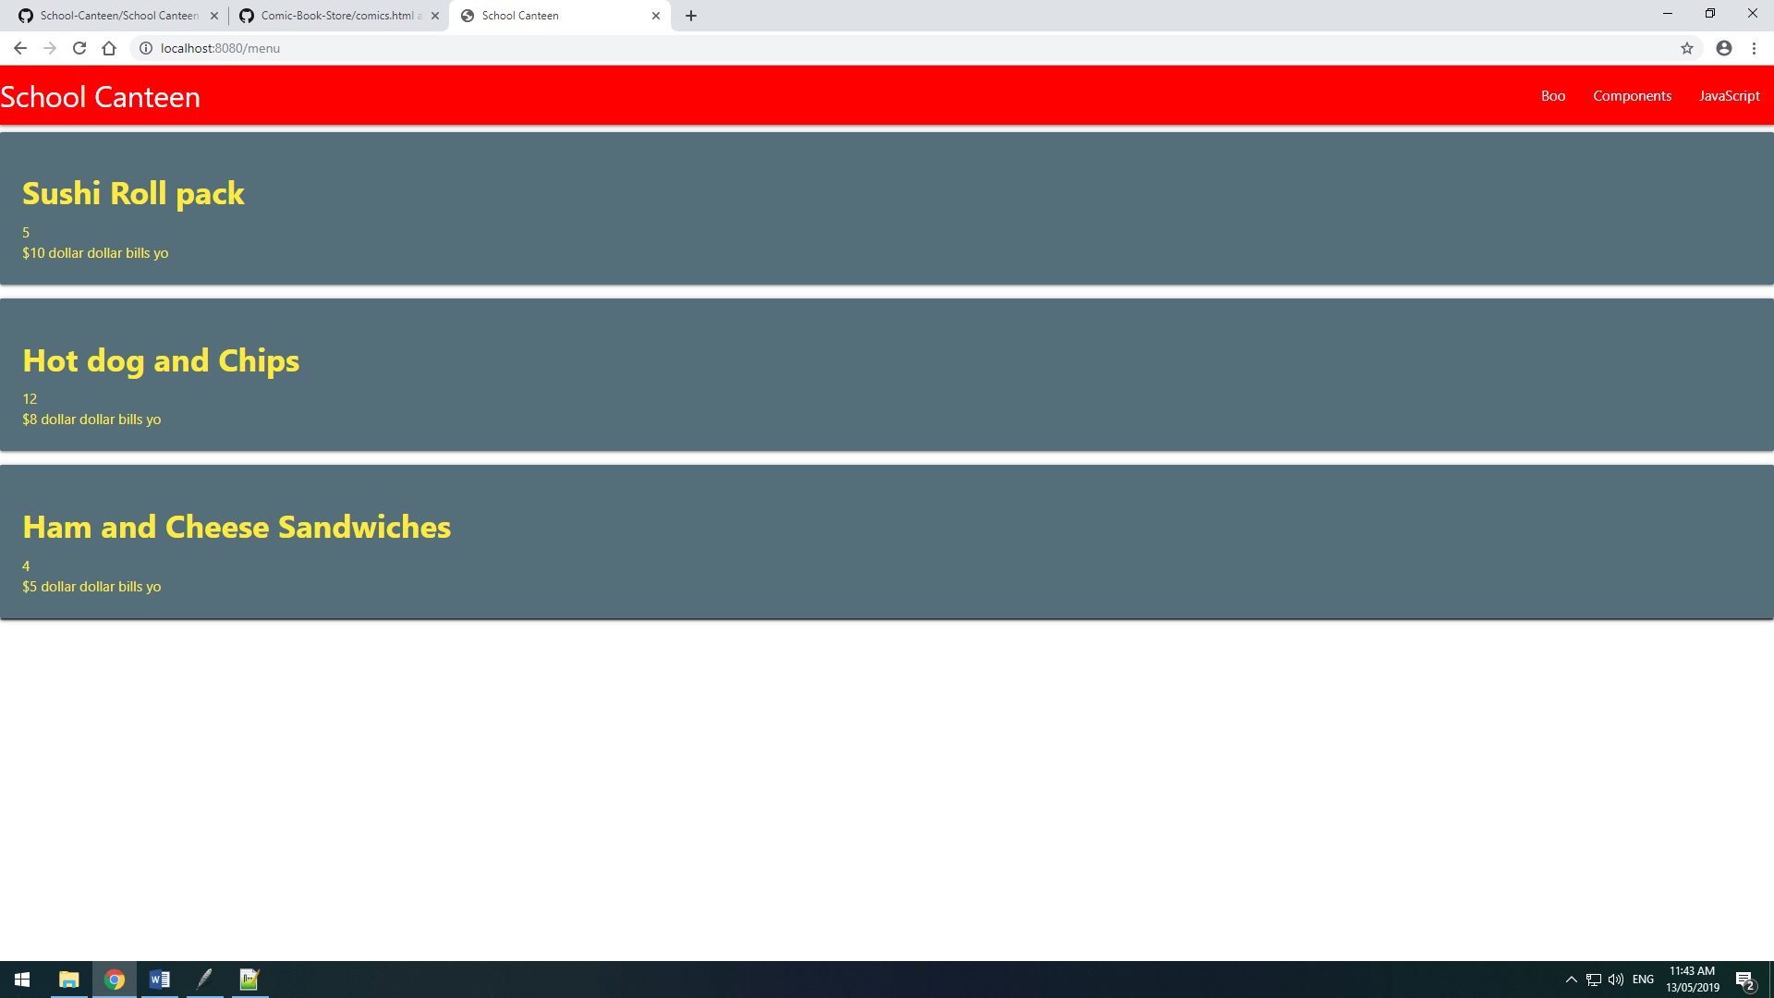

Task 14 : Evaluation

*How did your version turn out*

After fixing this coed